General Meeting
February 11, 2020 3:30 – 4:15
Honey Dew Library

In attendance: Katie Faraco-Hadlock, Michelle Brunner, Georgia Carlton, Amy Losoya, Kori Kickbush, Ivette Escobedo, Ana Mazon, Megan Haack, Brooke Argotsinger, Brooke Herman, Natasha Ramirez, Amy Smart, Kady Wright, Jenna Alleger, Danielle Hoyt, Matthew Jay Bryant, Anna Combest-Friedman, Alexis Rios, Sara Emerson, Karmonda Pearson, Christie Holbrook, Cami Kiel

Meeting called to order at: 3:30

Approval of minutes: Motion to approve by Matthew Jay Bryant. Seconded by Kori Kickbush. Approved.

Election: Nominees presented by chair. No further nominations from the floor.
Vice President – Amy Michelle Losoya elected vice president by unanimous vote.
Treasure – Michelle Animas elected treasurer by unanimous vote.
Secretary – Katherine Faraco-Hadlock elected secretary by unanimous vote.

Executive Board Appointments: The Co-presidents appointed Tonicia Yancey as Membership Chair and Ivette Escobedo as Hispanic Outreach Chair.
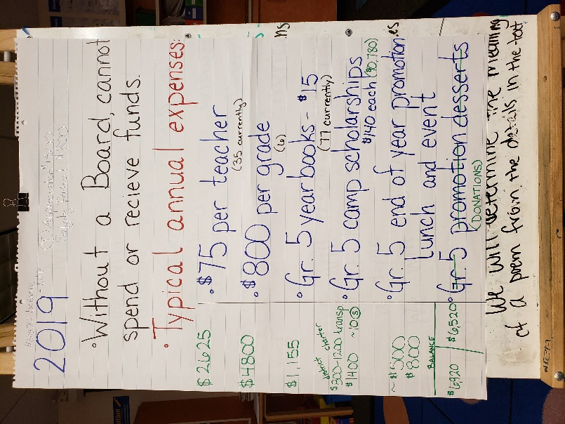
Treasurer’s Report:
Misty Mbadugha presented – see chart

A budget will be made for the next meeting, which will be presented for a vote from the general membership.

Membership Update:
35% staff membership
Schoolwide membership - all community members can be part of the PTA
$10 per member - both parents’ should be part of PTA
Teachers can turn in membership forms day of receipt. Misty to send out email to staff about collecting memberships and turning them into the office day of receipt.

New Business:
Walk-a-thon – donations are made as a flat donation; students walk for a while and get lap counters.
Amy Losoya moved for Honey Dew PTA to host a walk-a-thon this spring. Kori Kickbush seconded. Discussion of details followed. Donation through Member Planet is an option for families to make donations to our PTA. The motion passed.

Discussion of movie night. Lots of planning involved and need to pay for license. Does not make money, just breaks even. Will not hold this year. Movie licenses can be bought for the whole year and then used to show to kids during meetings.

Amy Smart moved that Honey Dew PTA host a Game Night. Ivette Escobedo seconded. Amy spoke to her motion. Discussion of simple planning and set up, low cost, and potential to raise some money through food sales. Date set as March 26th from 5-7. Possibly need to discuss nutrition guidelines for selling food and also food handling licenses. Possible games were brainstormed. The motion passed with unanimous support.

Smencils were discussed. Michelle Brunner will order smencils and sell them in the cafeteria the first Friday of every month from 9:45 – 10:00 possibly beginning April 3rd.

End of year carnival/BBQ event discussion tabled until budget is more finalized.

Announcements:
Next meeting is March 10th, the 2nd Tuesday of every month will be the schedule.

We need some people to look at the standing rules for possible revisions. Committee interest was sought.

Established committee for Game Night
Britnae Sanelli – Chair person
Amy Smart
Kim Motley
Ivette Escobedo

Established committee for Walk-A-thon
Natasha Ramirez
Tonicia Yancey
Jeremy Yancey

Meeting Adjourned: 4:18

